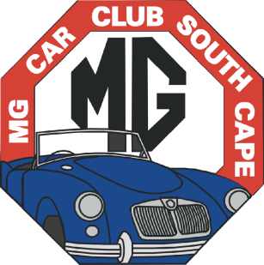
“Forever Young”
MG CAR CLUB
South Cape Centre
P O Box 58, Knysna, 6570.
www.mgcarclubsc.co.za

REGISTER OF CLUB CARS

Date:

Name of Registered Owner: Membership number:

DETAILS OF MG OWNED:

Model: Version:

Year: Registration No.:

Chassis (VIN) No.: S.A.Build No. (where applicable):

Engine No.:

Colour: Body: Upholstery:

Wheels: Wire Steel Alloy

Status of Car: Condition of car:

Awaiting rebuild
Being rebuilt
Running

Poor
Fair
Good
Excellent

City / town where car is kept:

