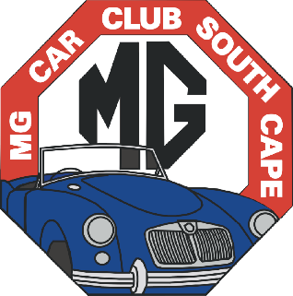
MG CAR CLUB
SOUTH CAPE CENTRE

P.O. BOX 58, KNYSNA, 6570

www.mgcarclubsc.co.za

MEMBERSHIP APPLICATION FORM

PLEASE PRINT
SURNAME | FIRST NAME | PREFERRED NAME |  |  | PARTNER
RESIDENTIAL
ADDRESS
RESIDENTIAL  ADDRESS | CODE:
POSTAL ADDRESS
POSTAL ADDRESS | CODE:
E-MAIL ADDRESS
PHONE HOME |  |  | PHONE WK.
CELL |  |  | FAX
BIRTHDAY | DAY: MONTH:

DETAILS OF MGs OWNED OR LOOKED AFTER:
 | YEAR | TYPE | BODY STYLE | COLOUR | OTHER
1
2

ARE YOU A MEMBER OF ANOTHER MG CLUB? IF YES, PLEASE GIVE DETAILS.
CLUB. | MEMBERSHIP No.

SIGNED |  | DATE

Tick Bank Details:
ENTRANCE FEE: Incl. Name badge. R100,00 |  |  | Name of Account | MG Car Club South Cape
SUBSCRIPTION FEE: R220,00* |  |  | Bank | Standard Bank
Add R10 if paying in cash, to cover bank charges |  |  | Account No. | 10177874242
 |  |  | Branch | 051 001
ADDITIONAL NAME BADGE R70,00# |  |  | NAME ON ADDNL.  BADGE

*Subscription: The Club year runs from 1 January to 31 December. If a new member joins after 1 July, the Subscription fee will be reduced to 50%. If joining after 1 November, full Subscription fee will be charged and taken as the following year’s subscription. If transferring from another MG Centre, no Entrance Fee is required. The Annual Subscription fee includes an eMail copy of monthly newsletter.
#Regalia: Entrance fee includes one name badge for the member. A variety of items, including apparel and car badges, are available, details of which can be found on the Club’s website or in the monthly newsletter. Any person requiring regalia should contact the Regalia Officer, Liesel Winter:eMail: southcapemgcarclub@gmail.com
Contact person: Tony Lyons-Lewis, Club Secretary: eMail: southcapemgcarclub@gmail.com

